eCMS MANUAL
Offence

Department of Revenue and Customs
Ministry of Finance
Table of Contents
1. Introduction 3
2. Offence routed through Inspection 3
2.1 Logging in as Custom Officer 3
2.2 Do the approval process of declaration 4
2.3 Payment 5
2.4 Valuation of the declaration 7
2.5 Centralized Risk 9
2.6 Inspection 10
3. Offence Management Module 14
3.1 Create Offence 14
3.2 Search Offence Report 14
3.3 Custom Warehouse procedure for detained goods 18
3.4 Seize process for detained goods 19
3.5 Release 27

Introduction
Offence module in Electronic Customs Management System (eCMS) allows Policy Sections to manage the complete lifecycle of an offence under Customs Rules and Regulations of Bhutan Revised Edition 2023. This module also enables Intelligence Agencies to report the offences. This module includes management of Offence Reports, processing of offence reports, Offence Case Files, managing inquiries, orders, notices etc. This user manual provides a detailed guide for Officers to work with this module.
Create Offence: -
  - eCMS enables an offence officer to complete offence reports that have been created by a declaration goods inspection failure reported by a customs officer.
  - eCMS also allows an offence officer to create ad-hoc offence reports due to risk/intelligence failure.
  - An offence can involve personnel or declaration goods.
  - The offence report will also contain the demand note to pay and the action applied on the goods involved.

Offence routed through Inspection

Logging in as Custom Officer
- The user needs to log into eCMS using the url: www.ecms.gov.bt
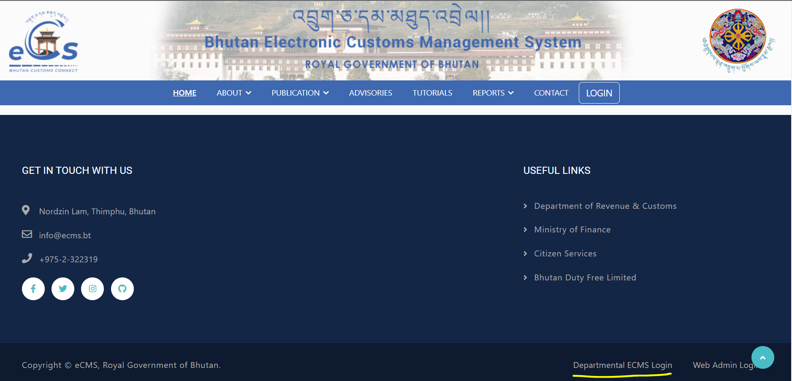
- Click on login menu and provide the required credentials to log in to the system:

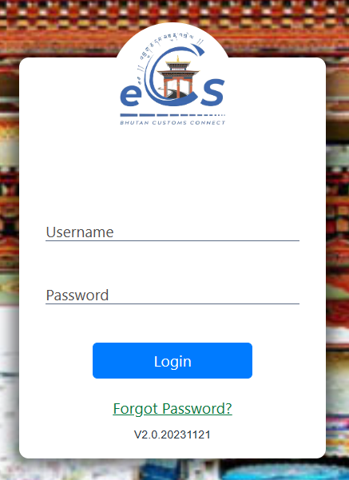

Do the approval process of declaration
- Approves / Rejects for Amendment/ Reject the declaration.
- In case of the different status:
  - Rejects for amendment the declaration is send back to the concern declarant with the remarks for rejection:
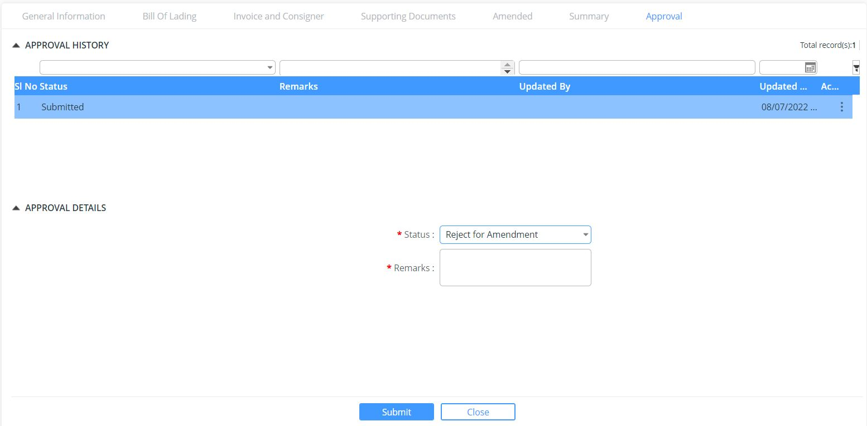
  - Reject: the declaration submitted is being rejected with remarks for rejection.
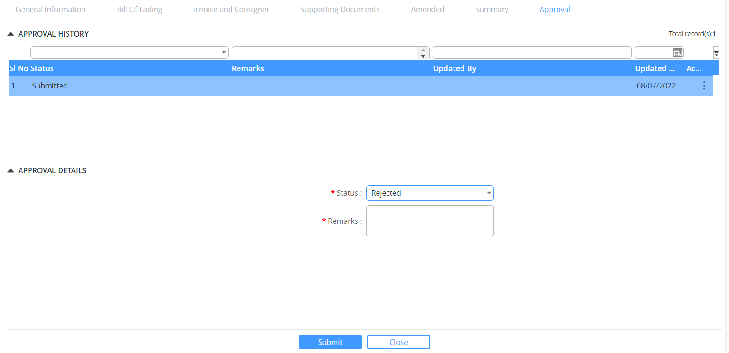
  - Approved: the declaration submitted has been approved and then moves for payment
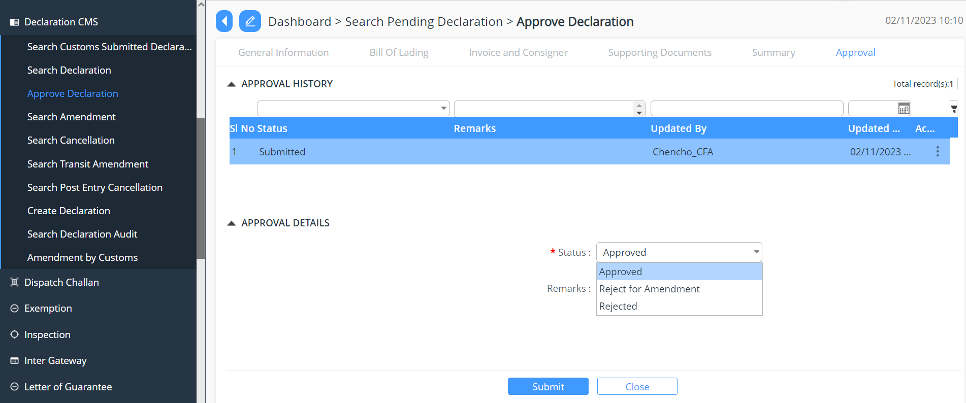

- Once approved payment needs to be proceeded with the generation of the receipt and share the same to the respective declarant via SMS and mail for payment.

Payment
- To do the same following are the steps:
  - Click >> Payment CMS
  - Select -> Pending Voucher -> Select the declaration for payment -> provide the details under each tab -> Payment number gets generated.
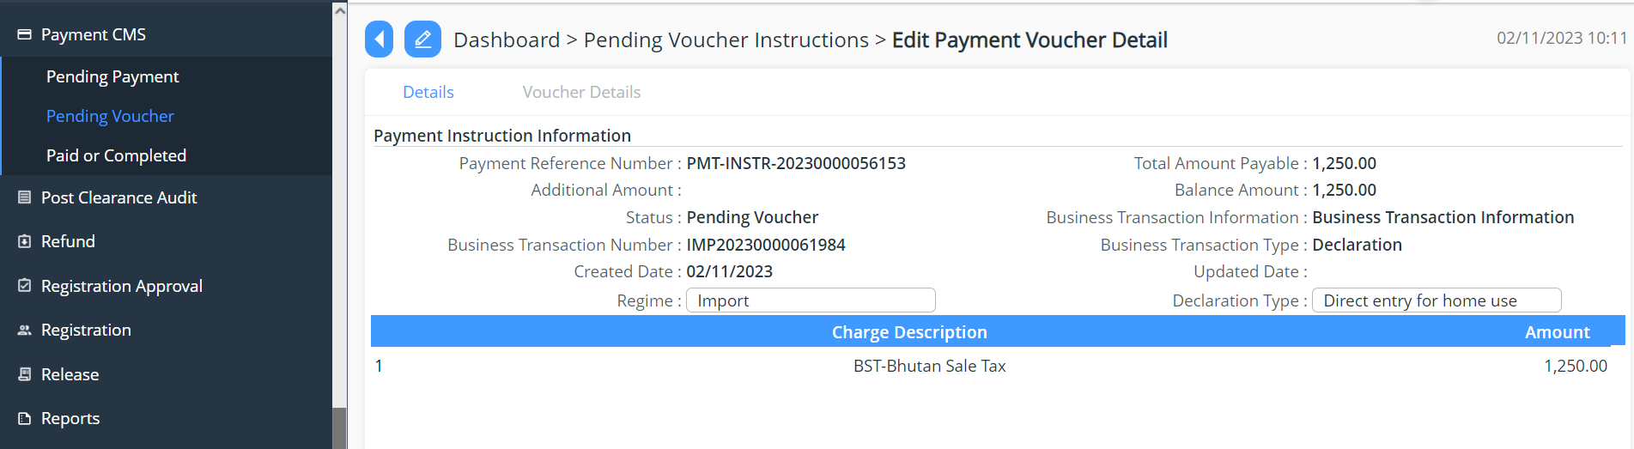
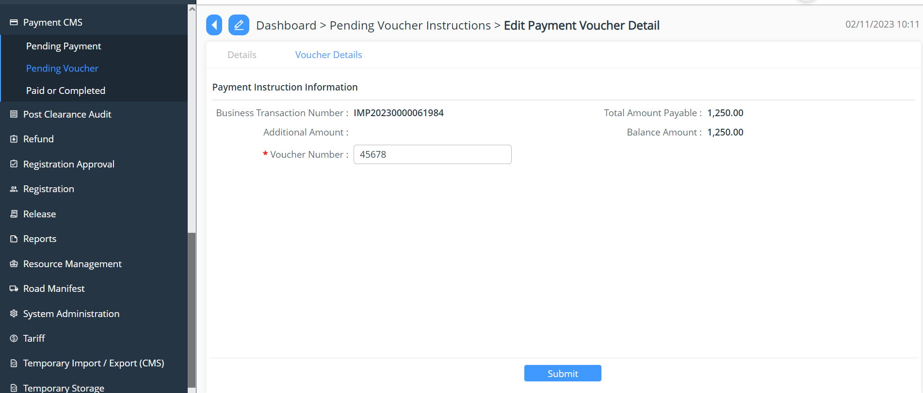
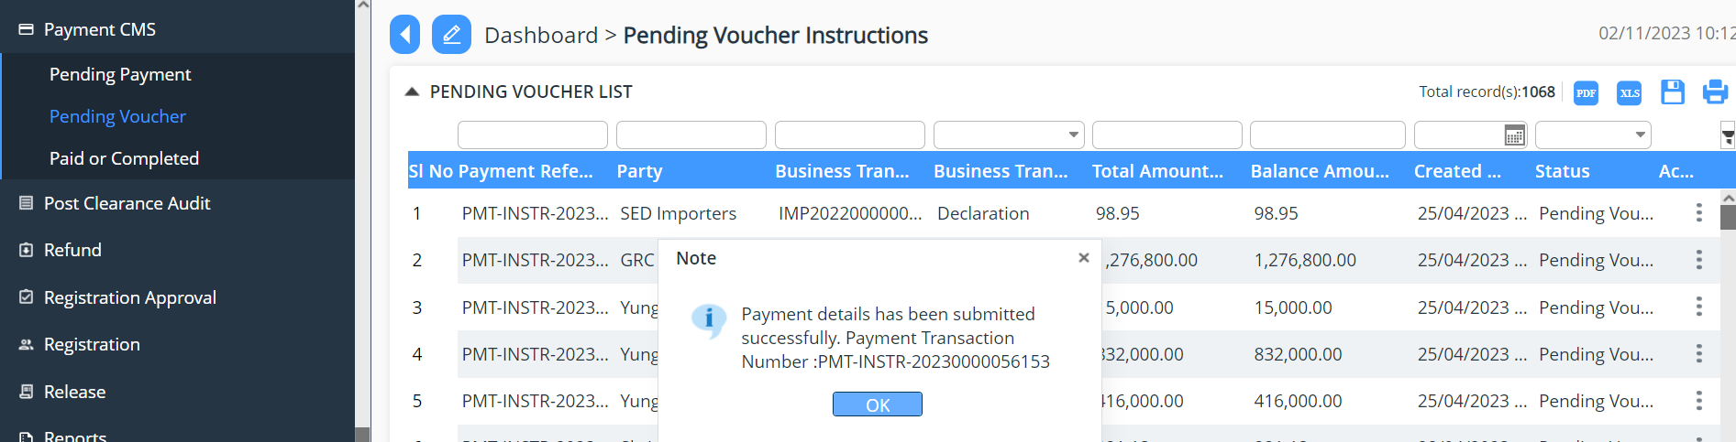

  - Select -> Pending Payment -> provide the required details and submit.
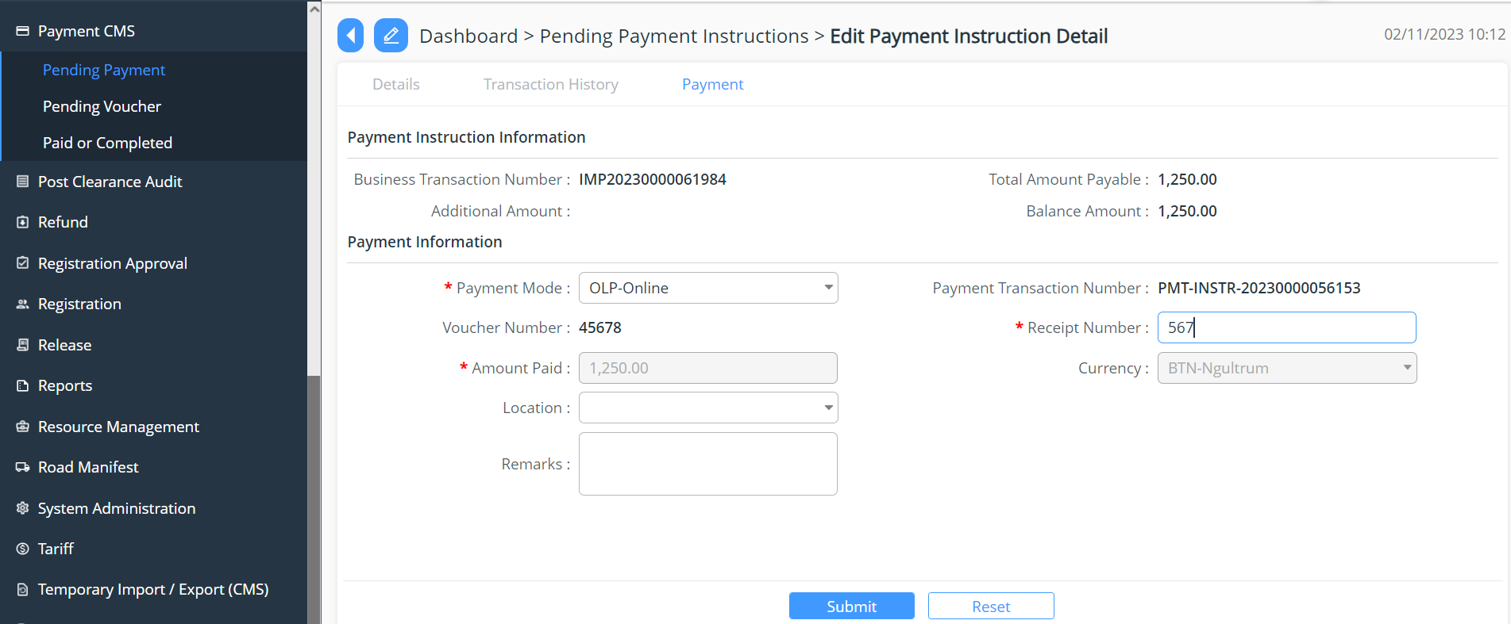

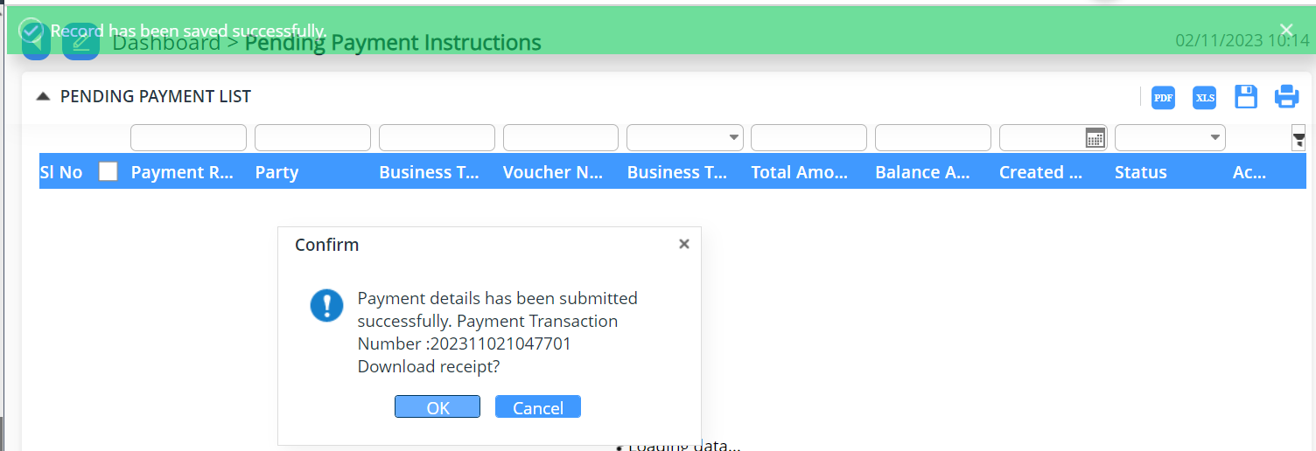

Valuation of the declaration
- The declaration moves to valuation tab, where in the concern officer will provide the details as per his/her finding from the valuation.

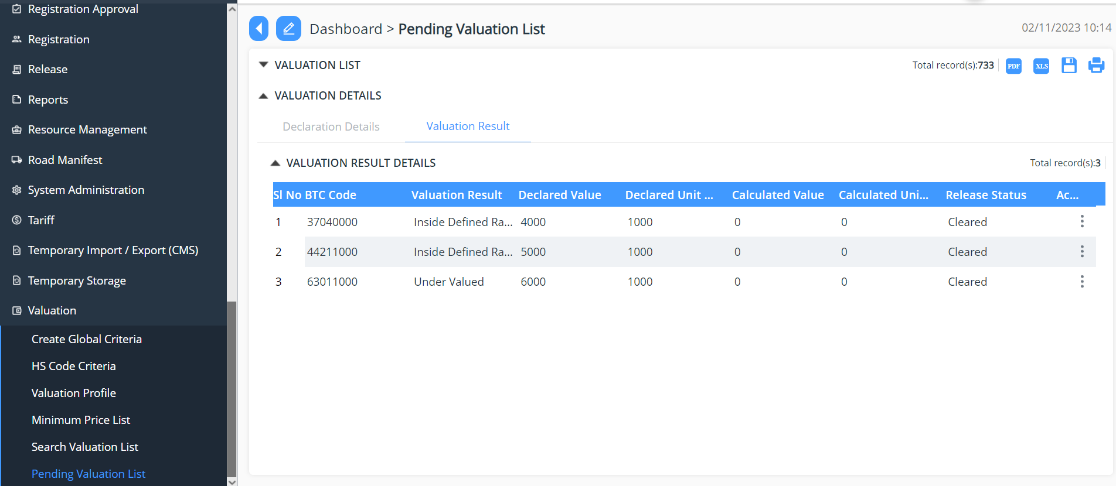

- Under valuation the list of items can be valuated, and the following are the finding:
  - All the items are evaluated individually, and data is also updated individually, for that:
    - Click >> Valuation Tab >> Select Pending Valuation List (list of declaration that needs to be valuated will be populated for the valuation)
    - Once selected the valuation details has the tab:
- Declaration Details: provided the details for declaration and declaration date:
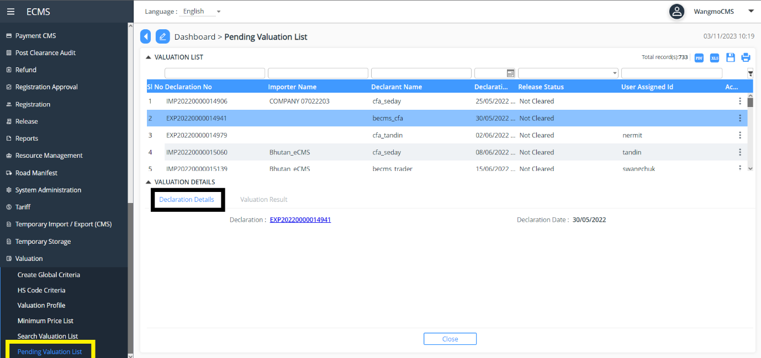
- Valuation Result: Here in the list of items from the declaration that needs to be evaluated.
- Select -> Item from the list of items from the declaration.
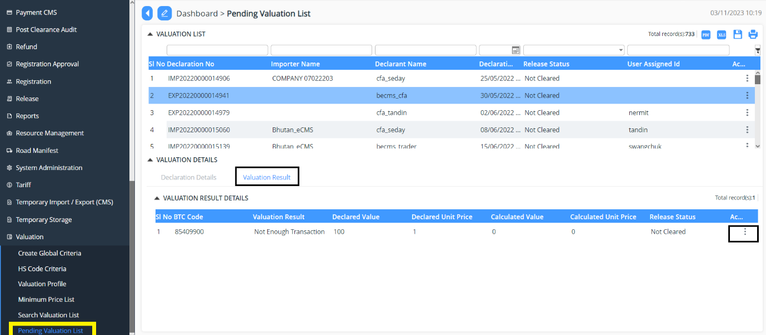

- The details pop up that needs to be filled in with the valuation data:
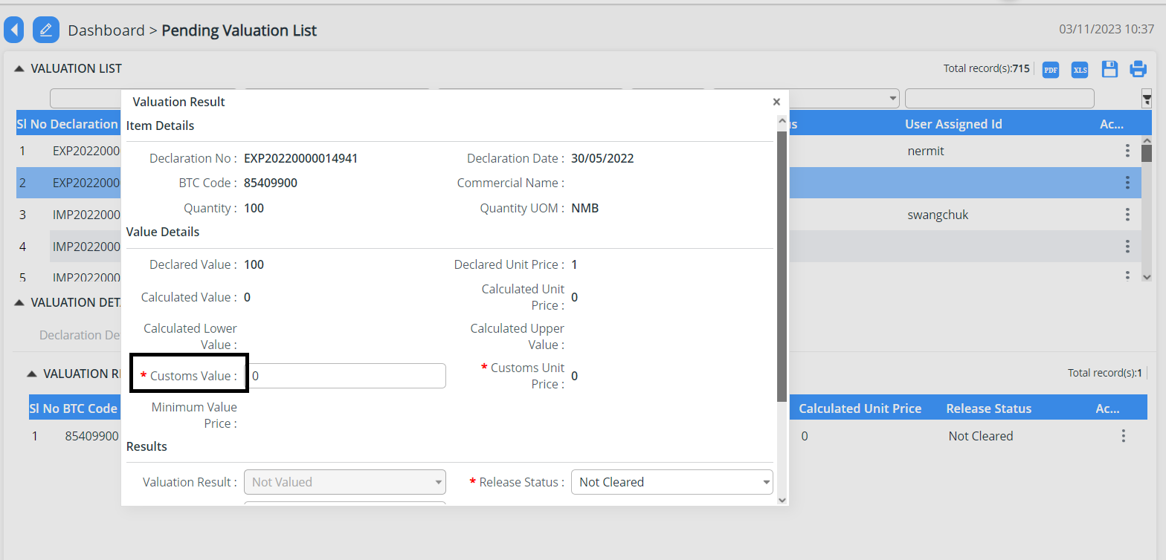

- Here in Custom Value needs to be added in as per the valuation.
- Once the value is added the Result Tab, selected the details and update the same.
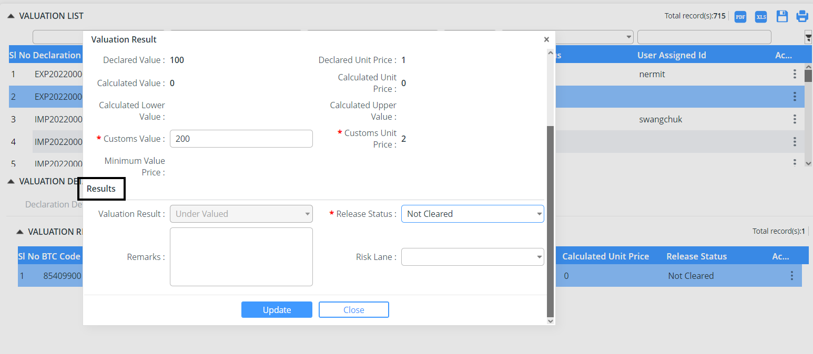

- After the valuation is done and any of the item is found to be as follows:
          - Inside Define Range – The item gets cleared.
          - Under Value - then it will go further for Risk assessment.

Centralized Risk
  - Click >> Centralized Risk
  - Select -> Pending Risk Assessment
  - Under Pending Risk Assessment
    - Fill in the details for the Risk Assessment as per the details required and update the declaration

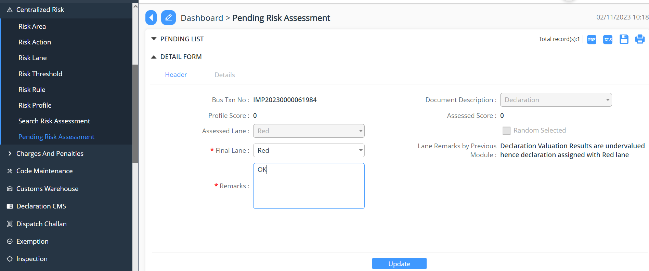

Inspection
  - Click >> Inspection.
  - Select >> Create Physical Examination.
  - Fill in all the details:
            - Header:
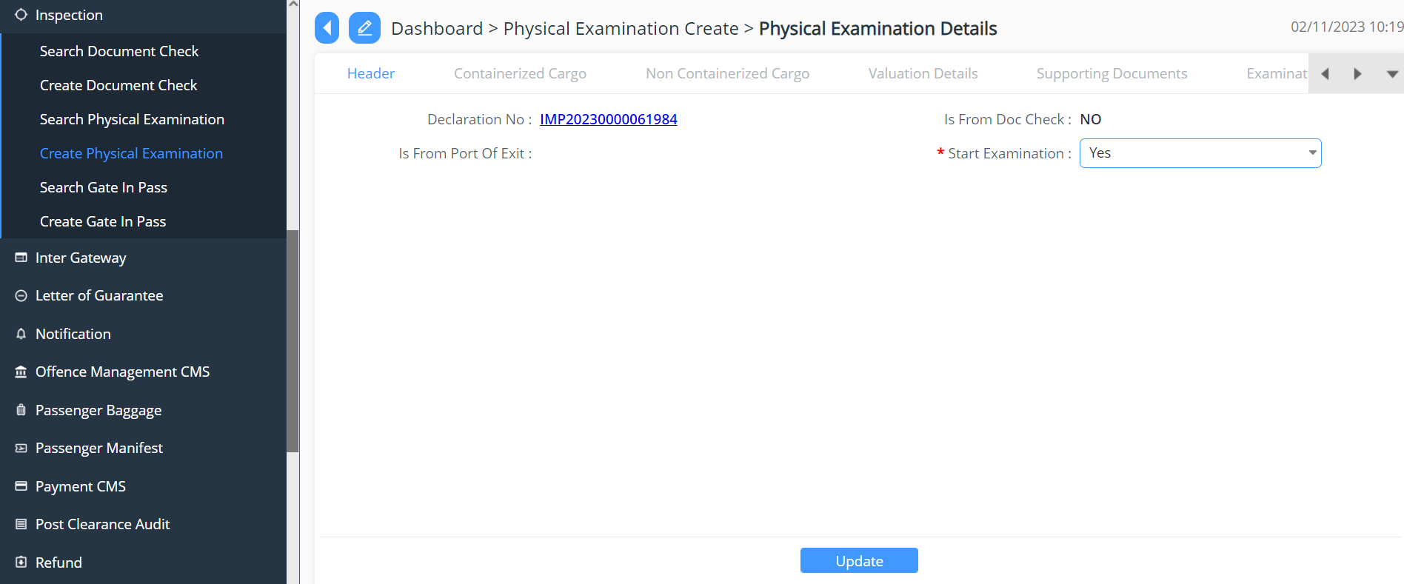
            - Containerized Cargo
            - Non-Containerized Cargo
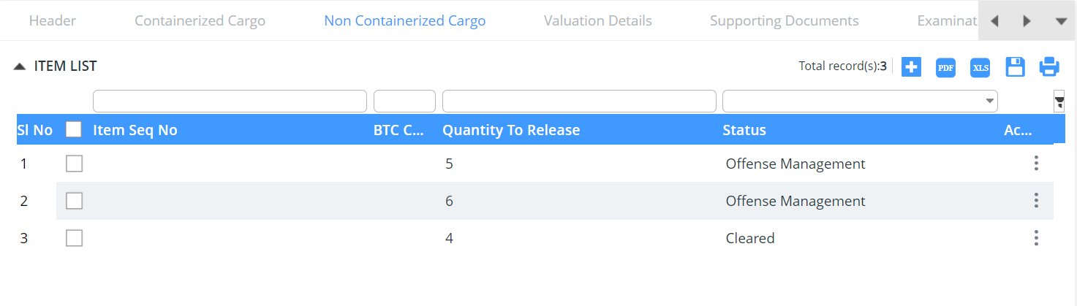
            - Valuation Details
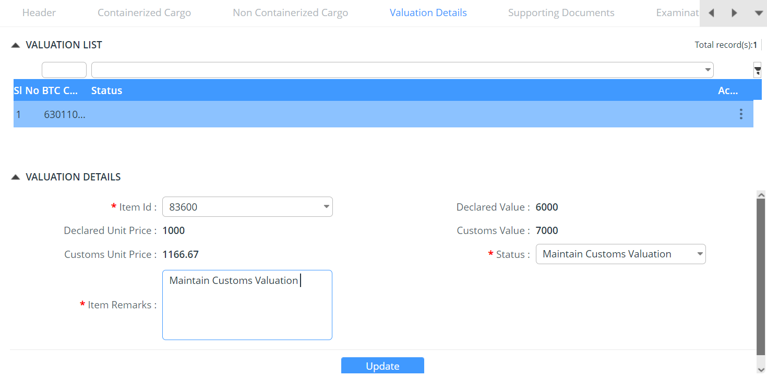
            - Support Documents: attach the document required.
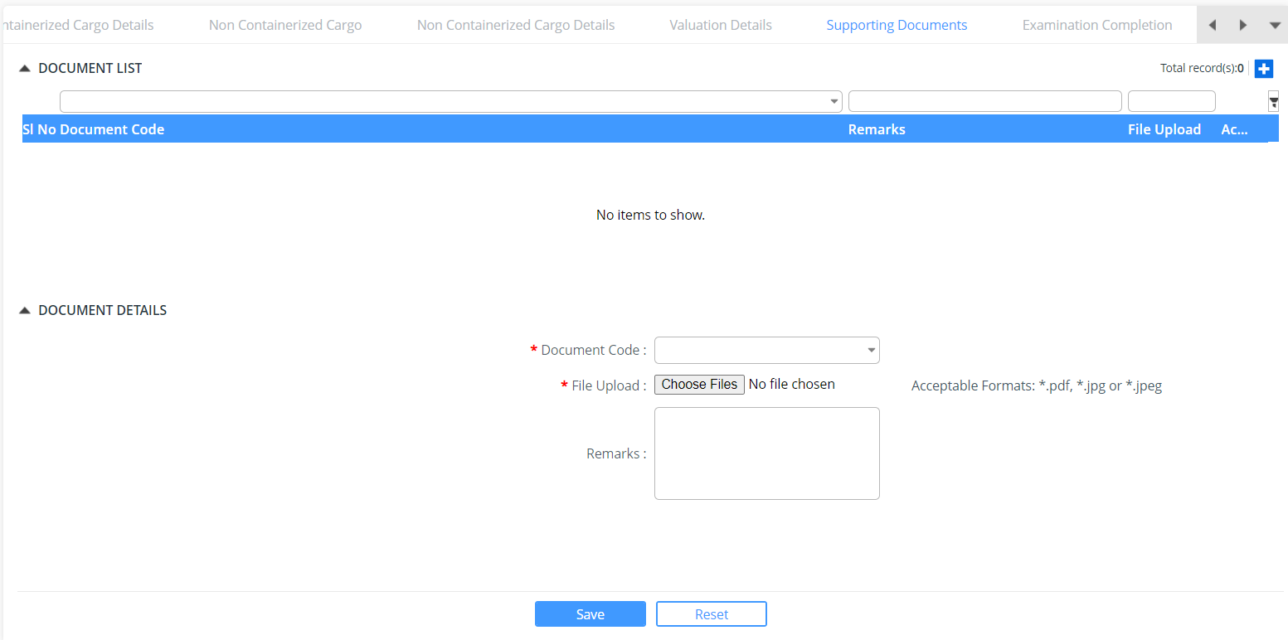
            - Examination: here under the Physical Examination Status = Physical Examination failed (Amendment/Offence)

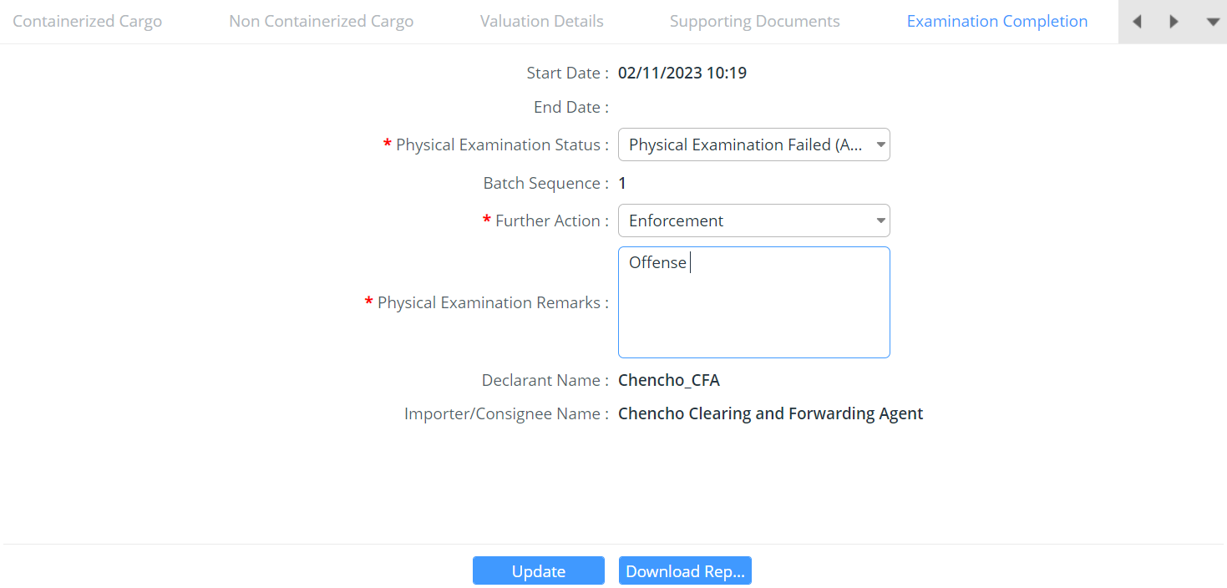
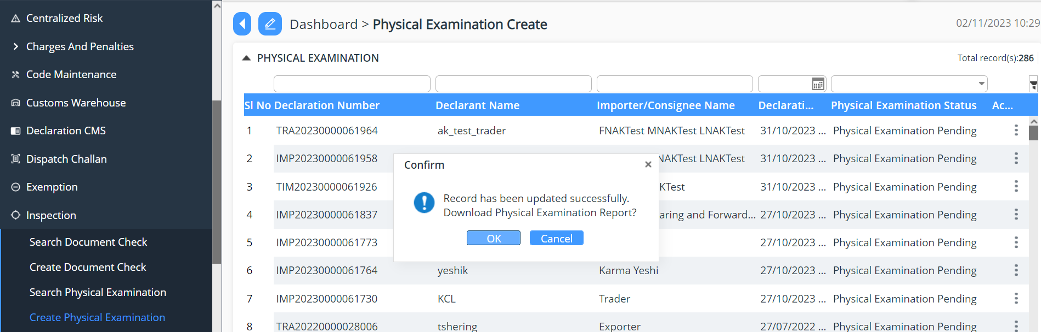

            - Print out of the Physical Examination Report

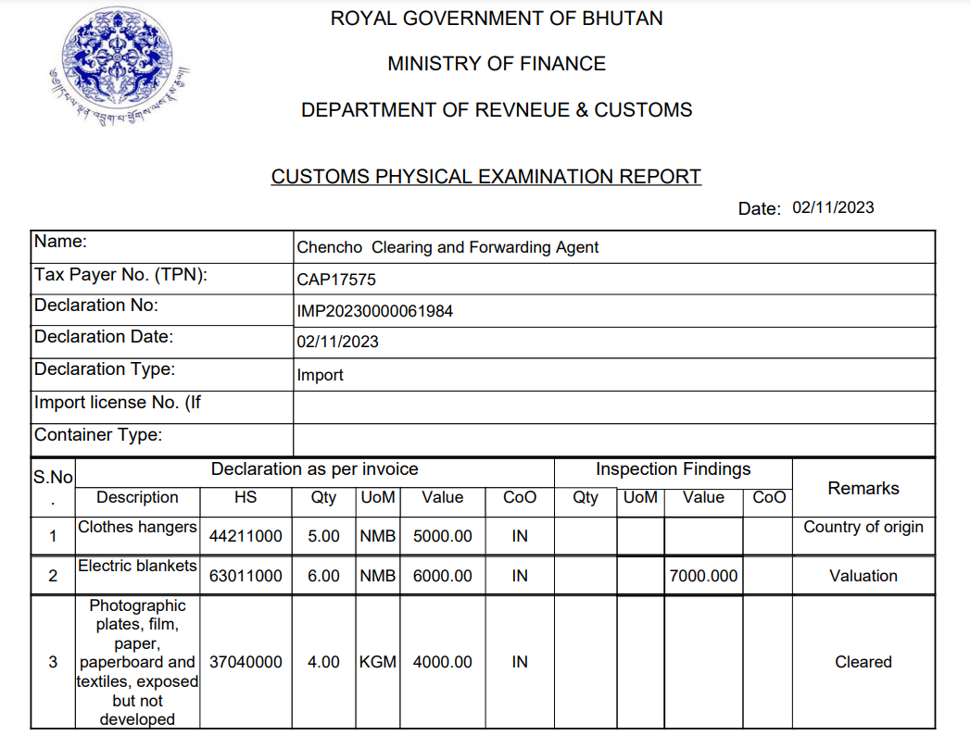

Offence Management Module

Create Offence
- Select -> Create Offence
- Select the declaration which has been routed through inspection for offence and click on Create
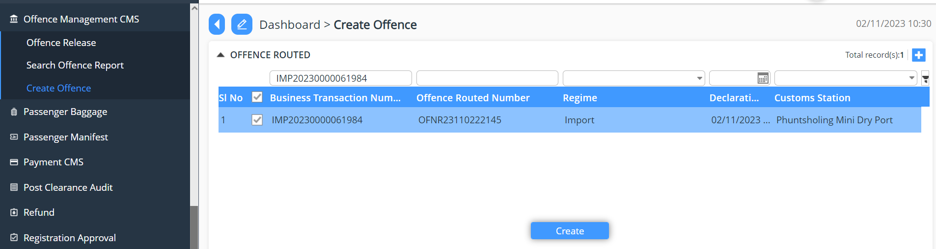

- Offence is being created:
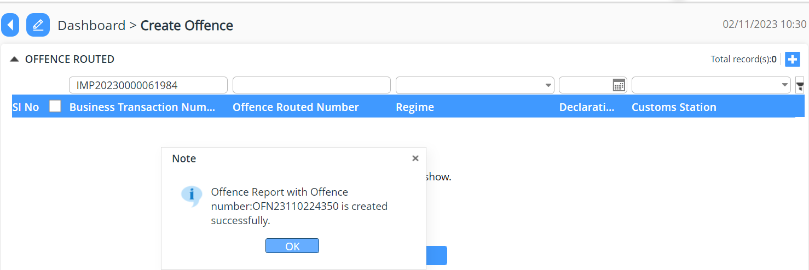

Search Offence Report
- Gives the list of declaration under offence.
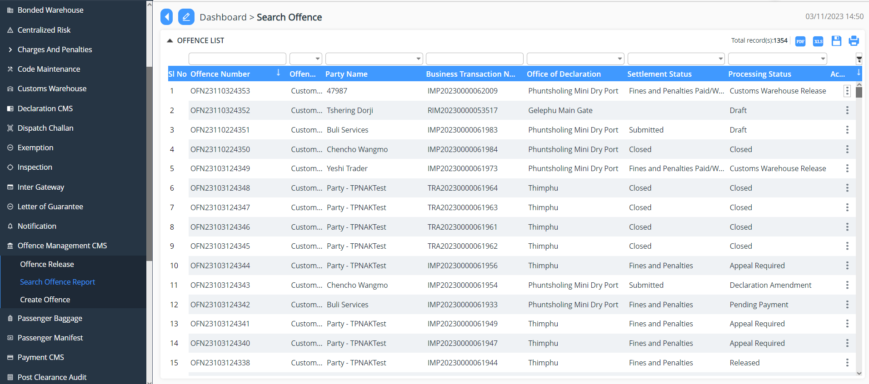
- Shows the list of offence that has been committed.
- Select the Offence that has been committed.
- Add in details on the offence as per the finding and Click on Update button.
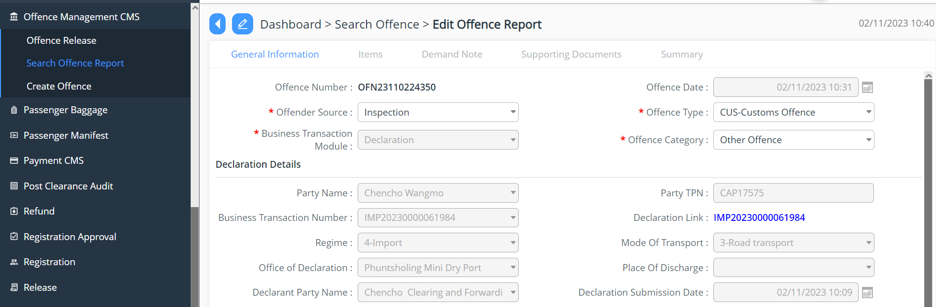
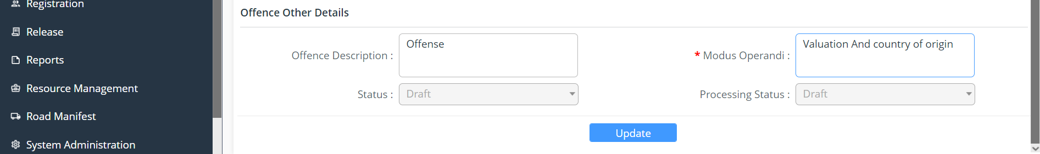
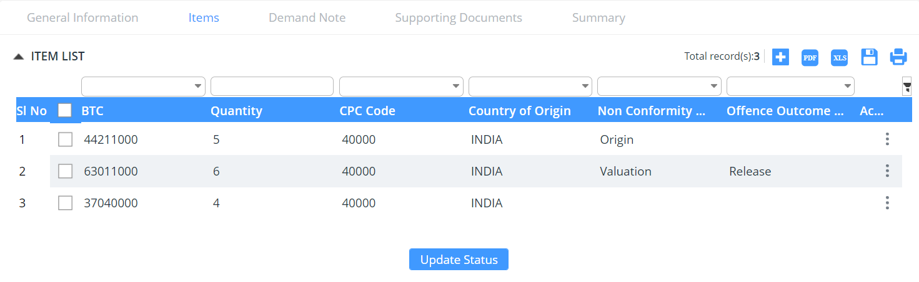

- Assuming Offence here in each item level:
- Item 1 (Origin) – here the item has issue with origin so that has been recorded and provided with outcome as Detention and now will be shared to the Custom Warehouse.

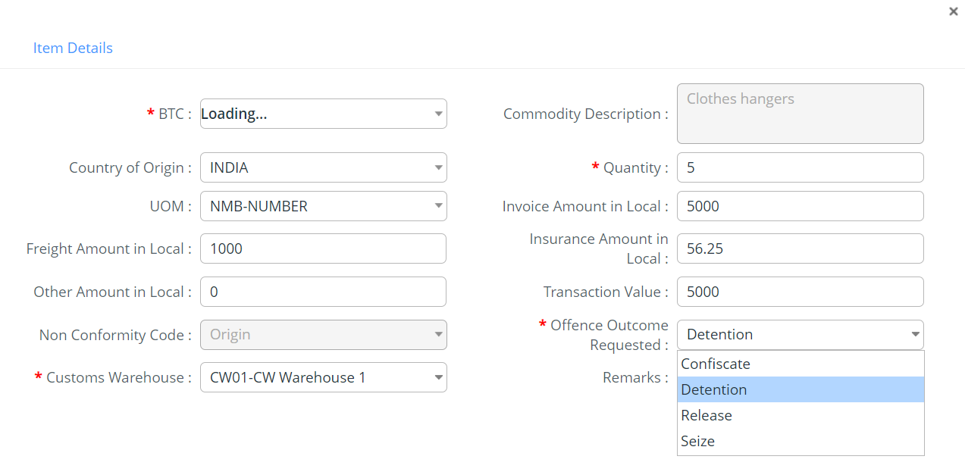
- Item 2 (Valuation) – if the item has valuation offence, the item will be detained and send to Custom Warehouse

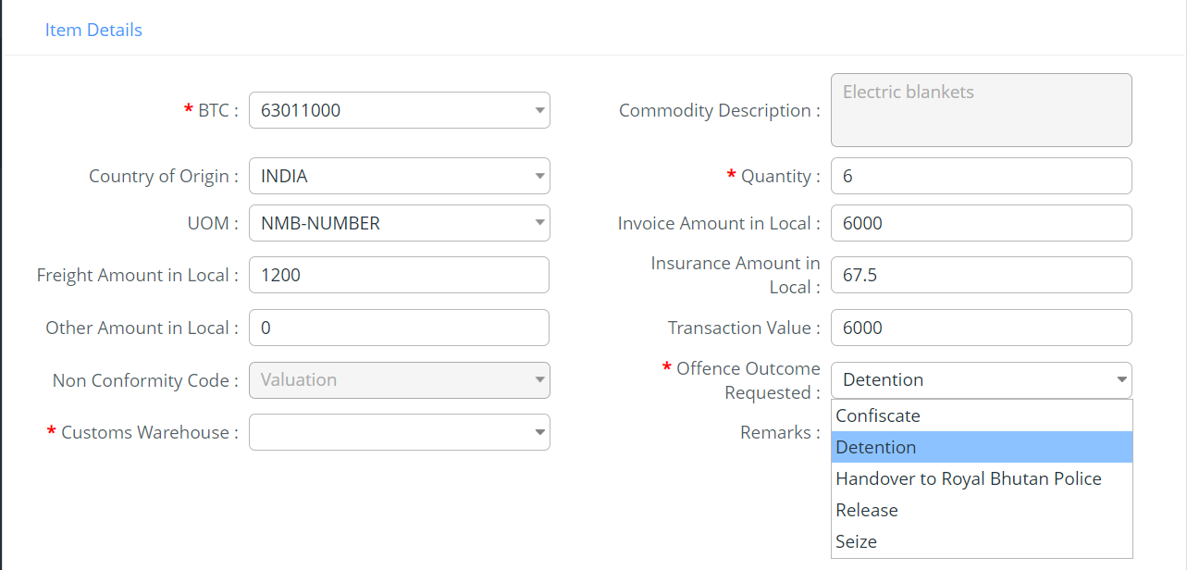

- Item 3 (Cleared) : if the item has no issue , it clear and the outcome of the item is updated as Released
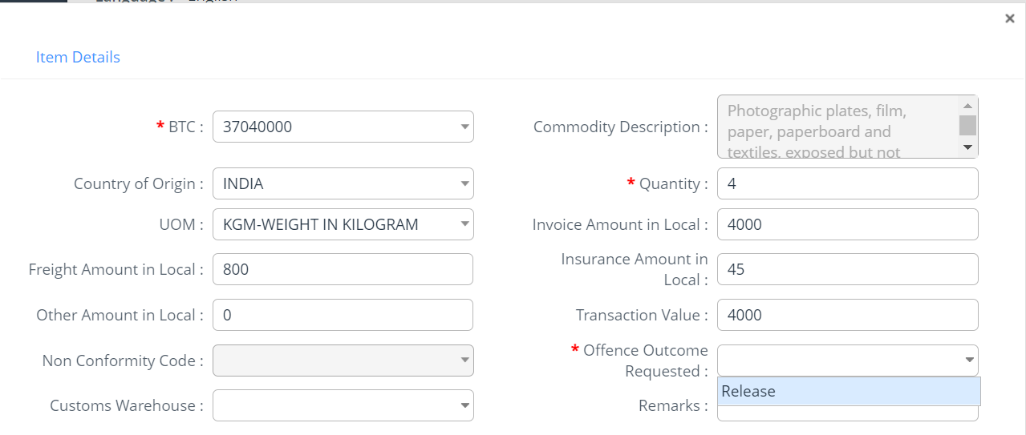

- Under Summary tab – provides the summary of the offence that has been created.
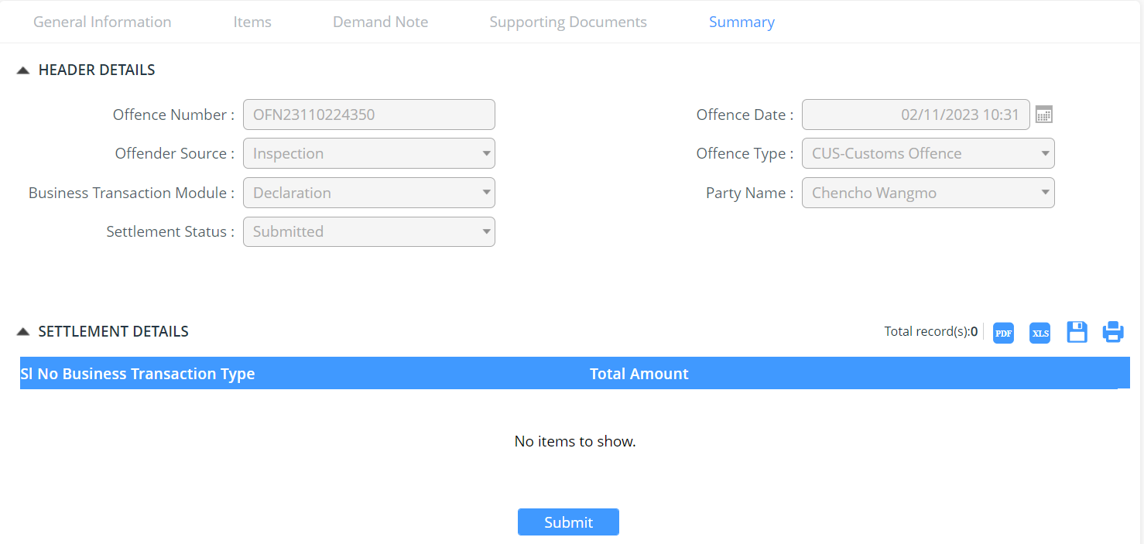

- To check for the status offence, get the details from the list by providing the offence number as below:
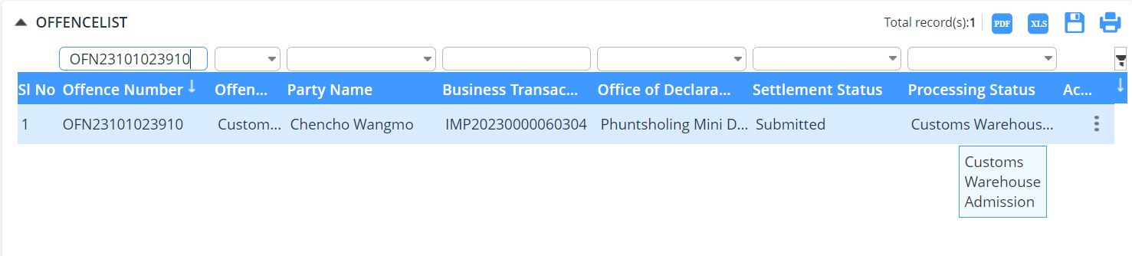

The Item that has been detained will now be added to the Custom Warehouse via concern authority.

Custom Warehouse procedure for detained goods
Click >> Customs Warehouse
Select -> Admit Goods

List of declaration with item gets populated and the item under each is being admitted to the warehouse.

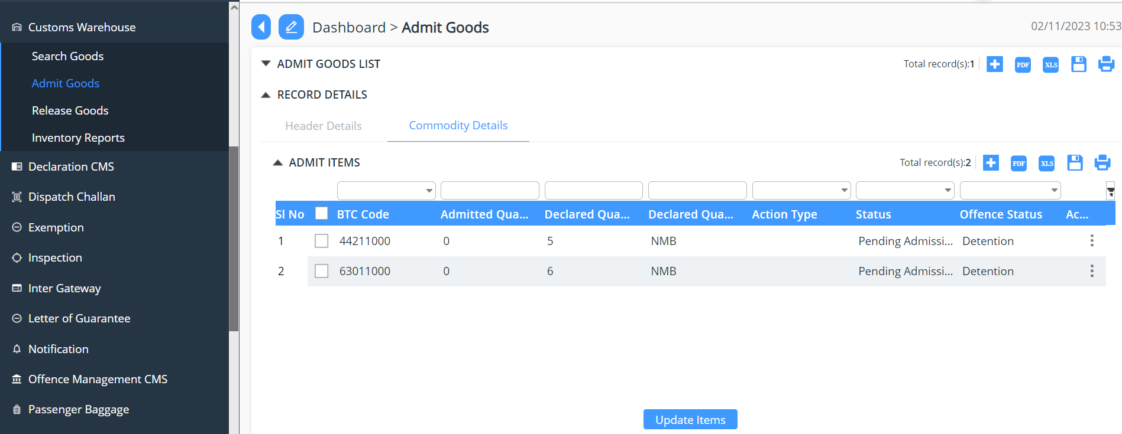

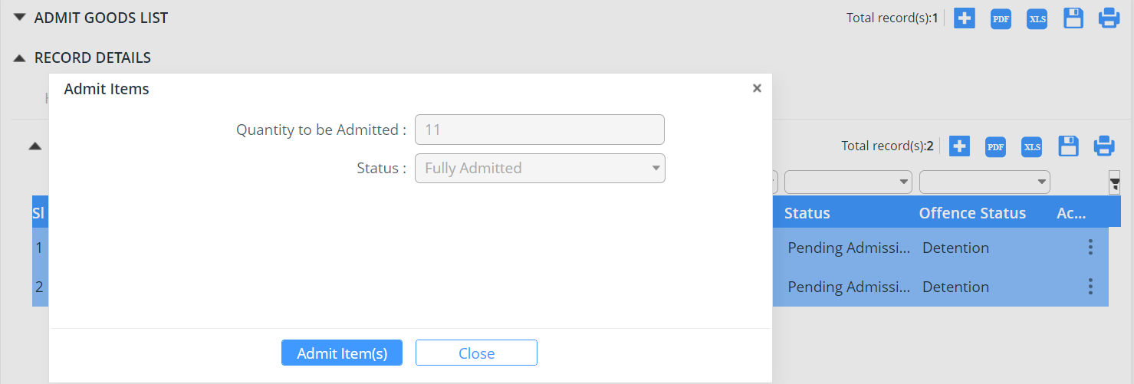

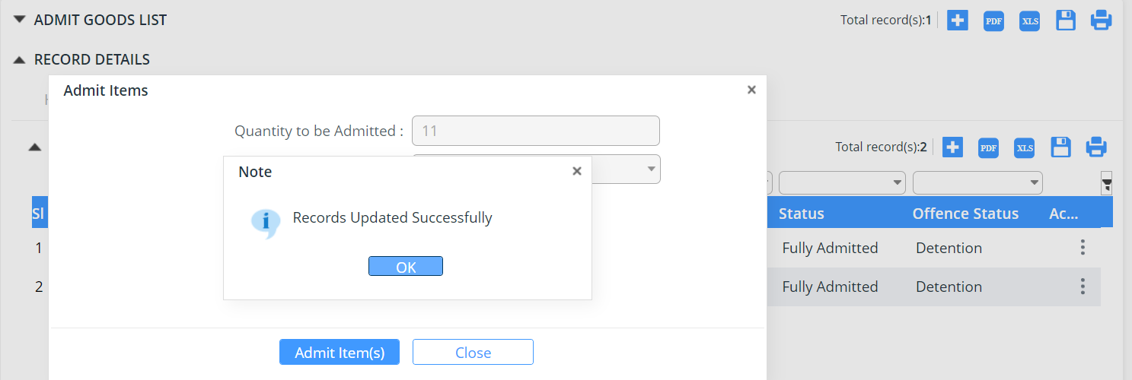

Seize process for detained goods
The Offence gets reopened to check for the outcome by the concern officer, the status now will be changed from Detention to Seize.

Click >> Offence Management System
Select -> Search Offence Report
Select the Offence that need to be worked onto
Under the item change the Offence Outcome Requested as: Seize.

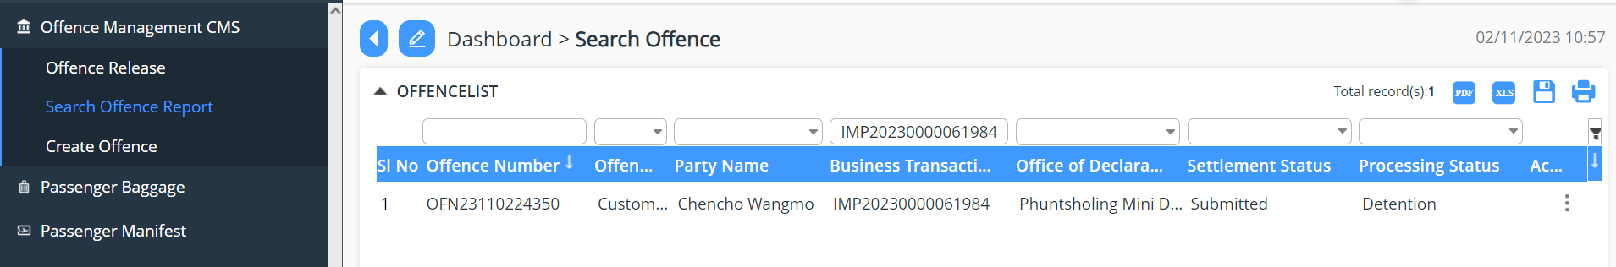
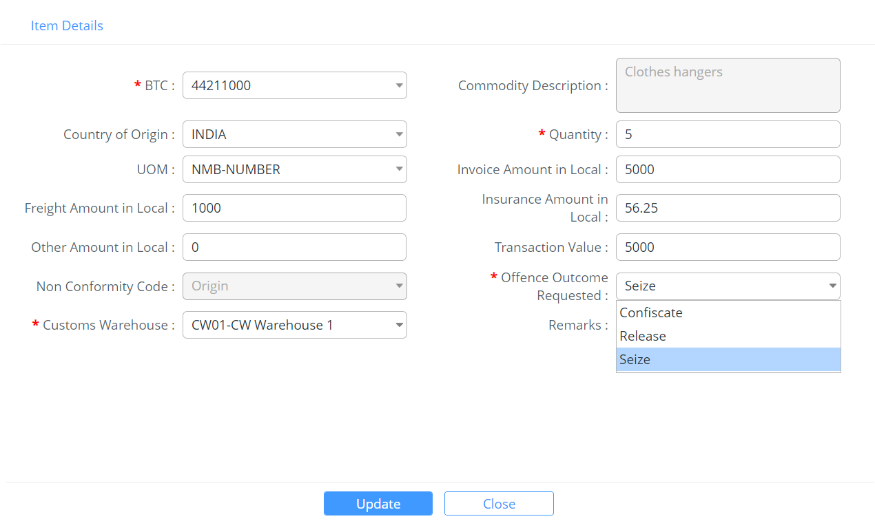
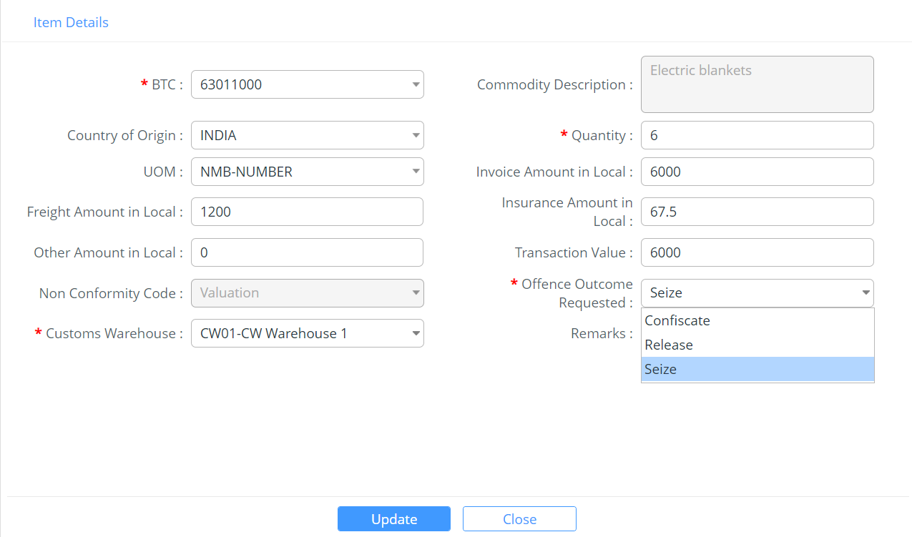
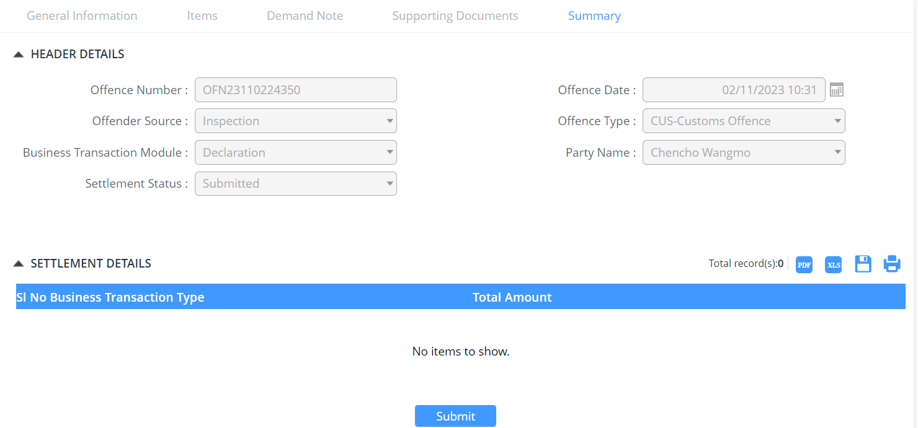

The concern officer will now take the declaration and check for the status, here the status that will be shown is Declaration Amendment as shown below:

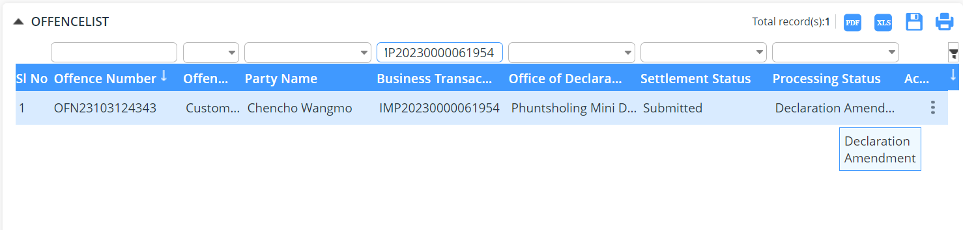

Got to Declaration CMS >> Select Amendment by Customs
Do the changes into the item where in the office was committed, in our case we have item1 having origin and item2 having under value.
Here under the declaration the amendment is made by the concern official.
            - General information no change

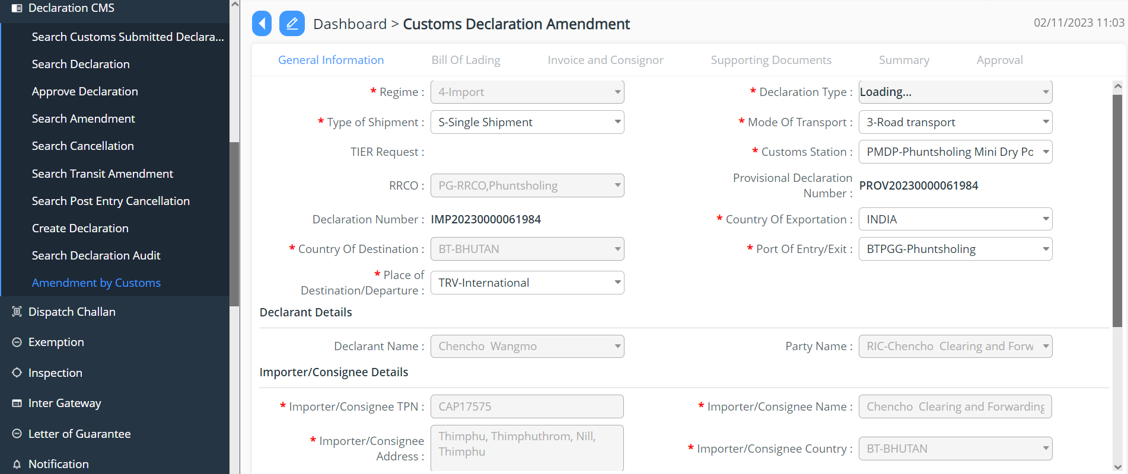
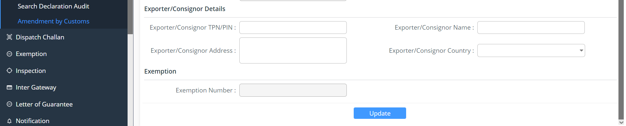

            - Bill of landing
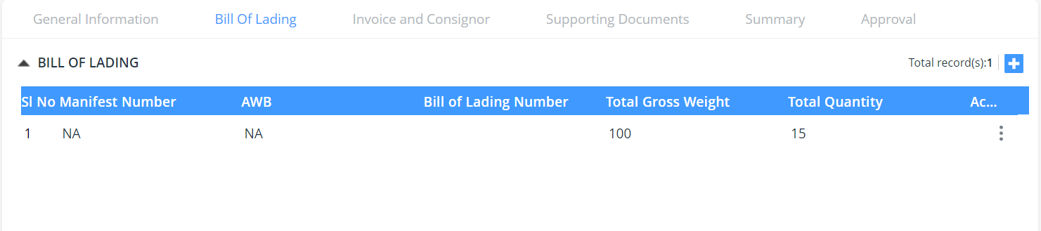

            - Invoice and Consignor – as there was offence under item, update needs to be made on the item level.
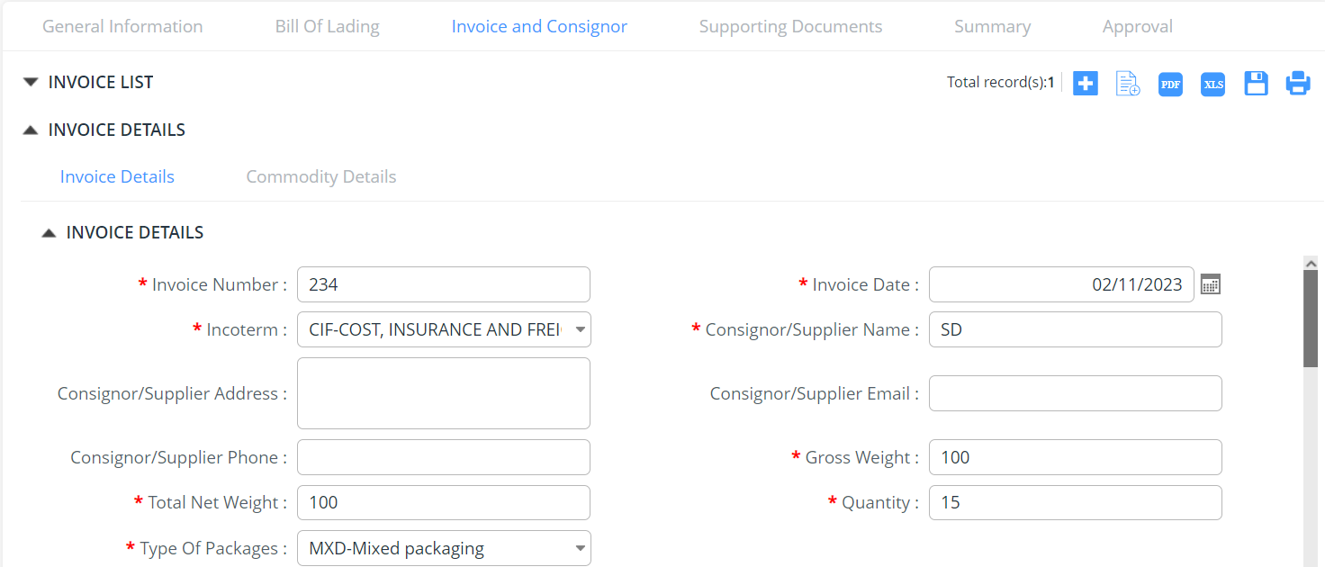
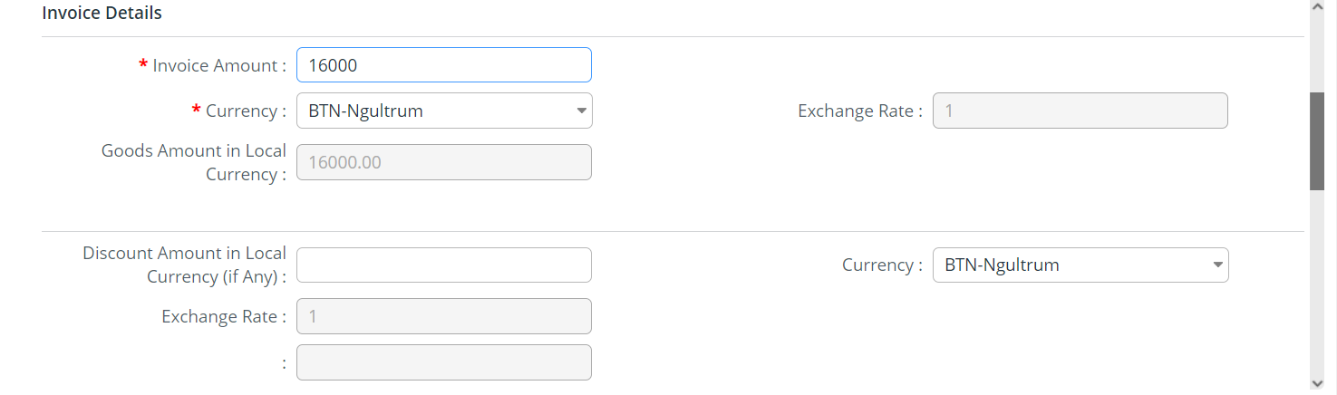
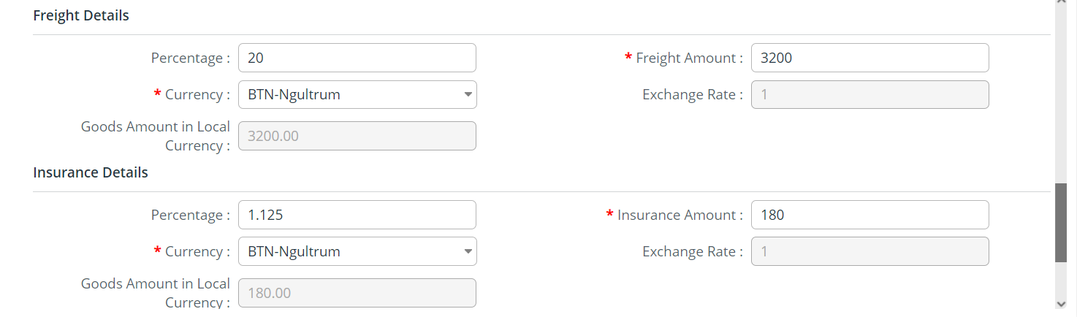
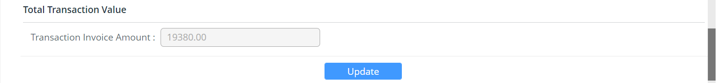
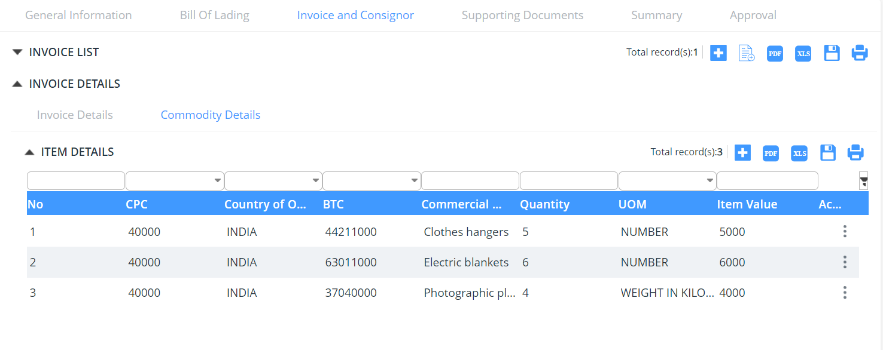
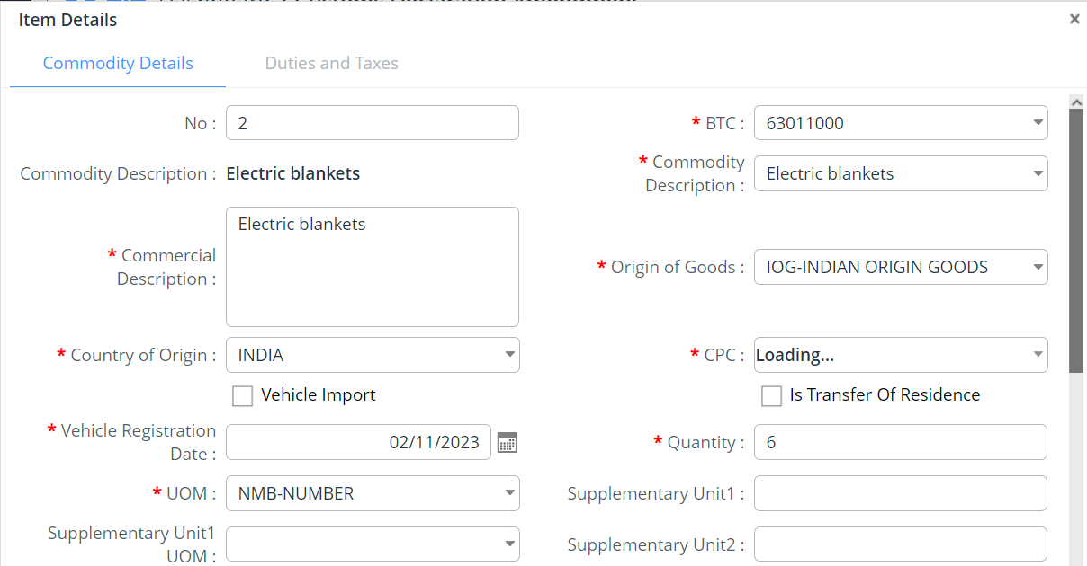
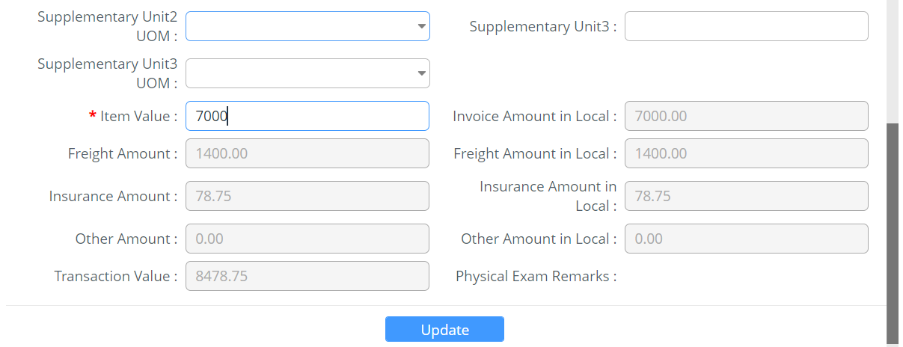
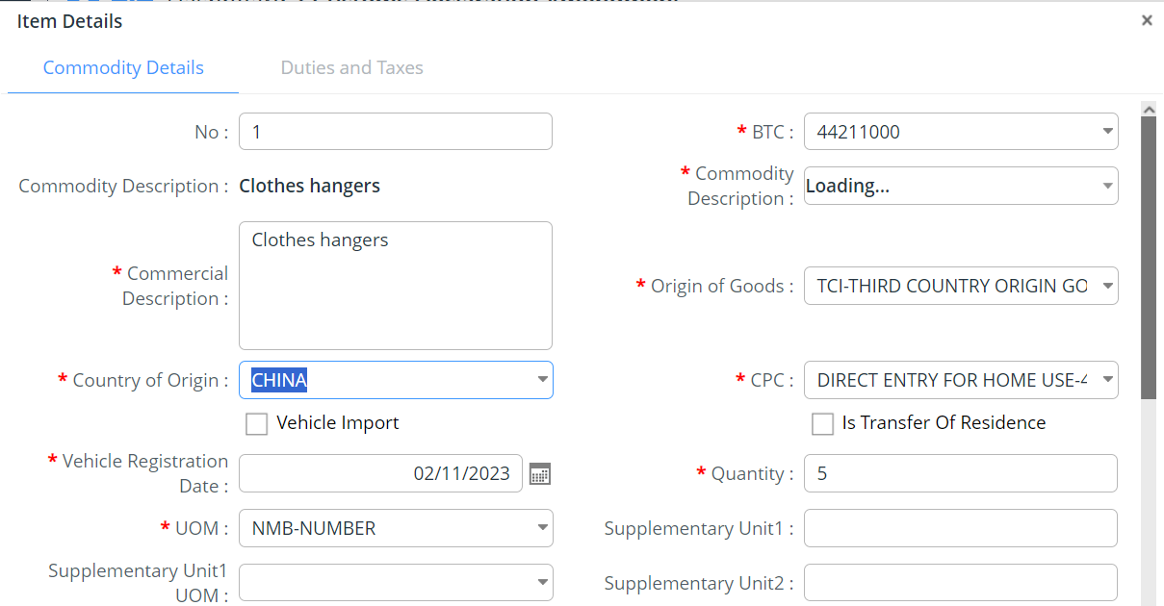
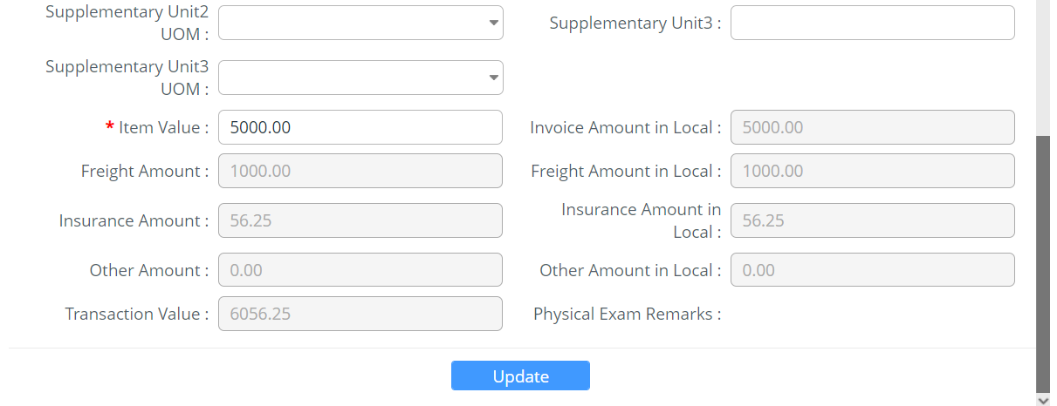
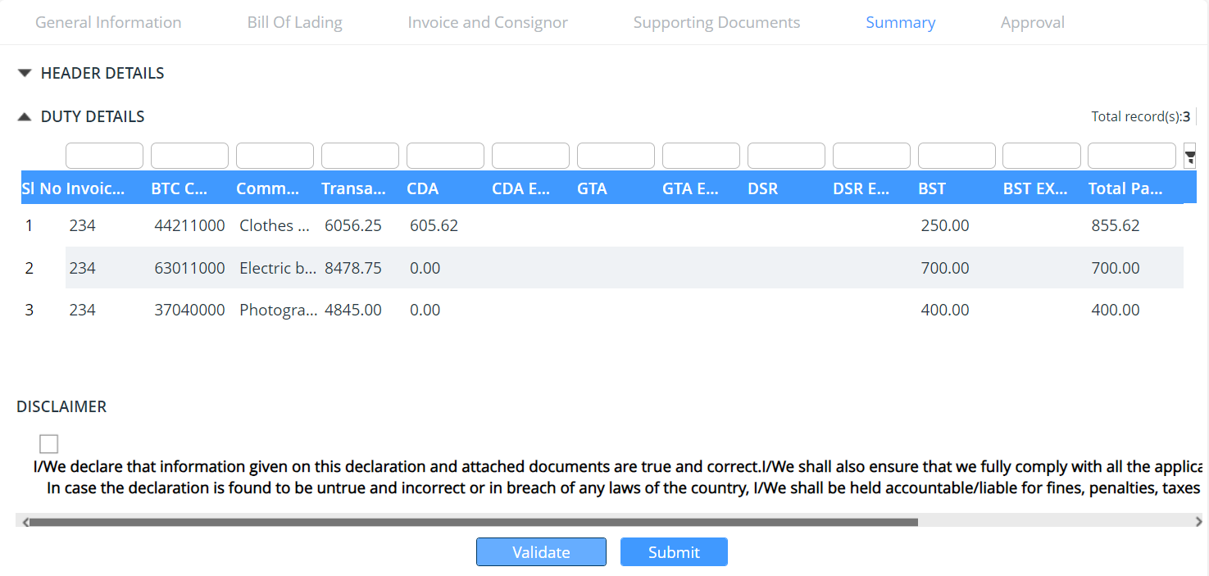

Amendment completed.

The Status of the declaration will now be pending payment there was valuation mismatch.

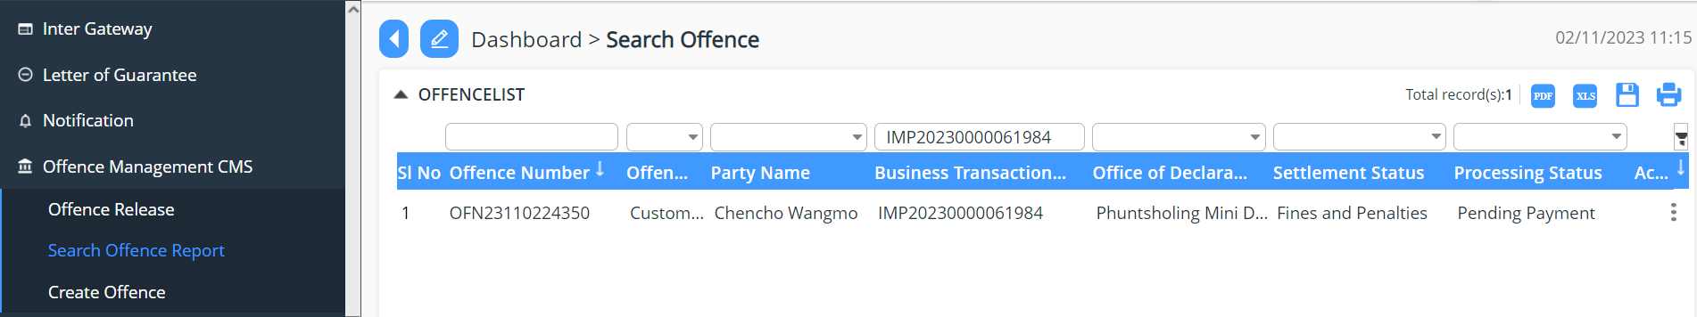

Next Go to Payment CMS, make the additional payment and submit.

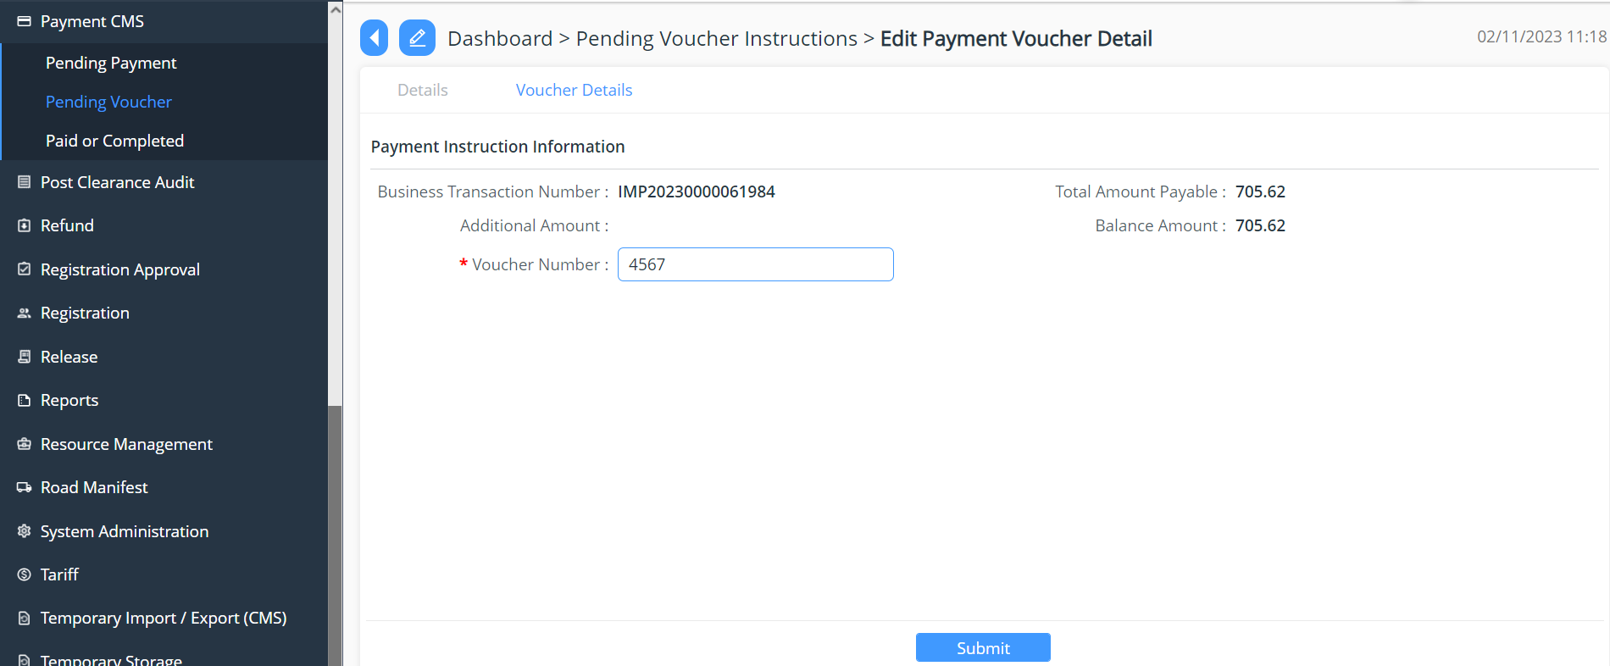
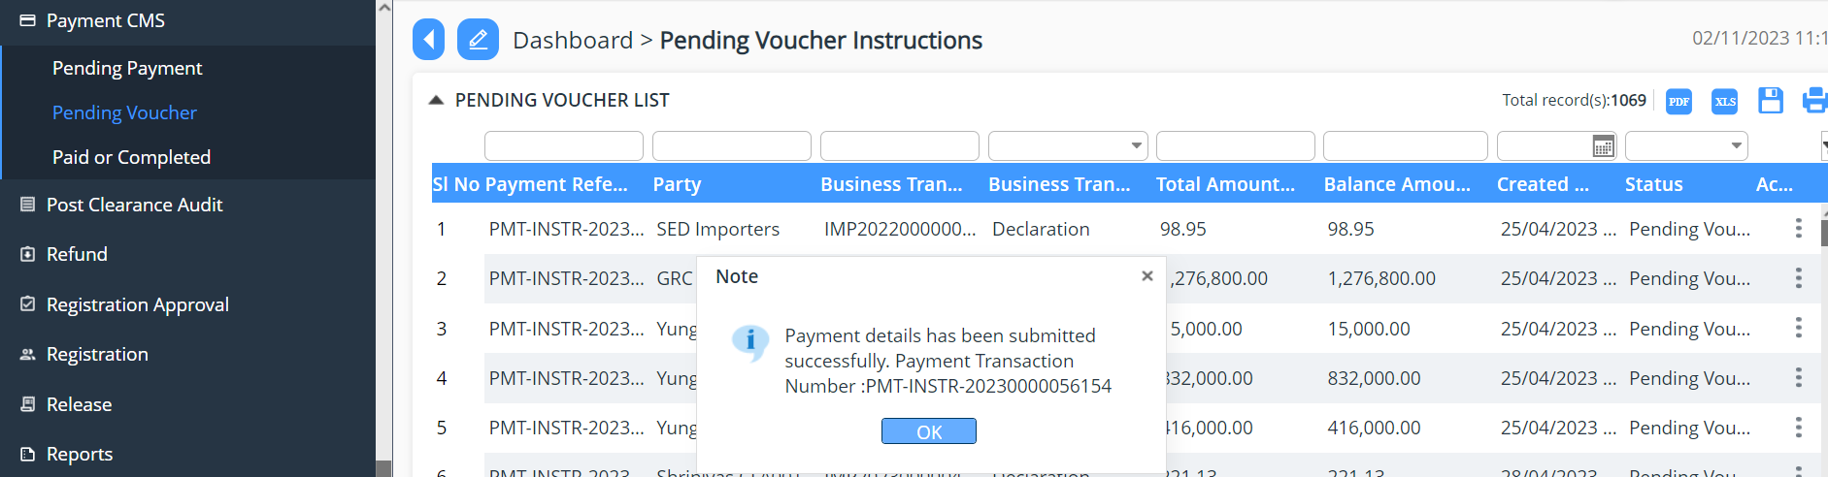
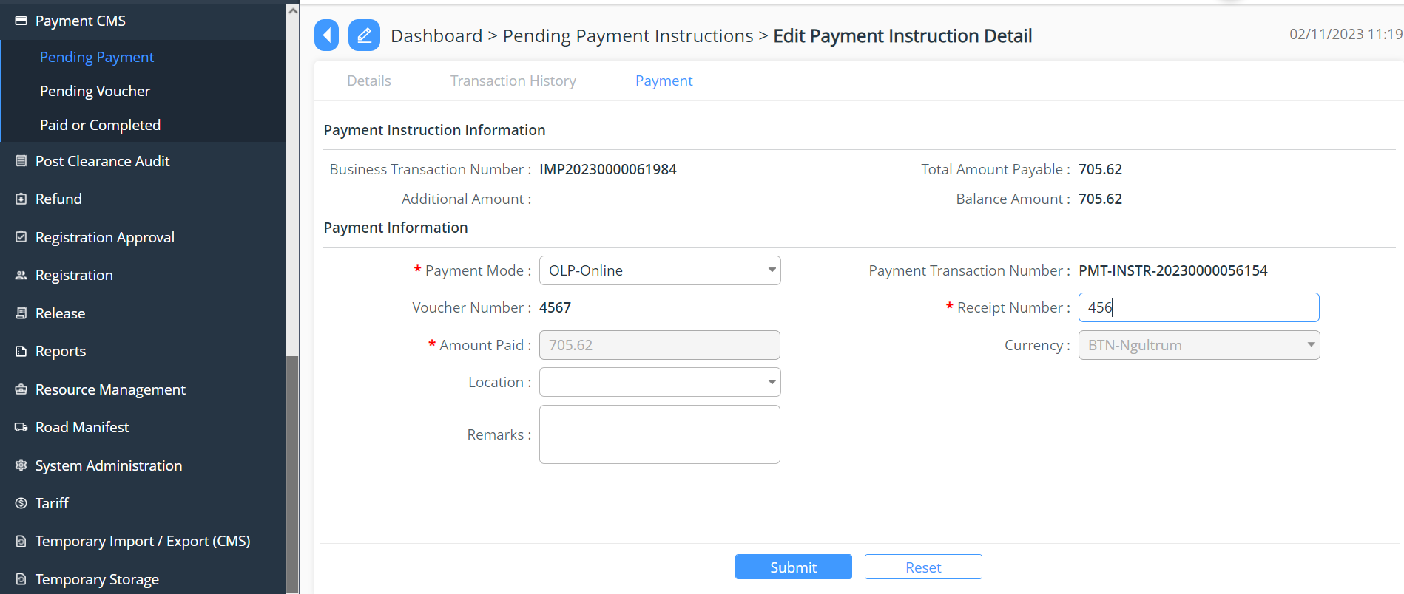

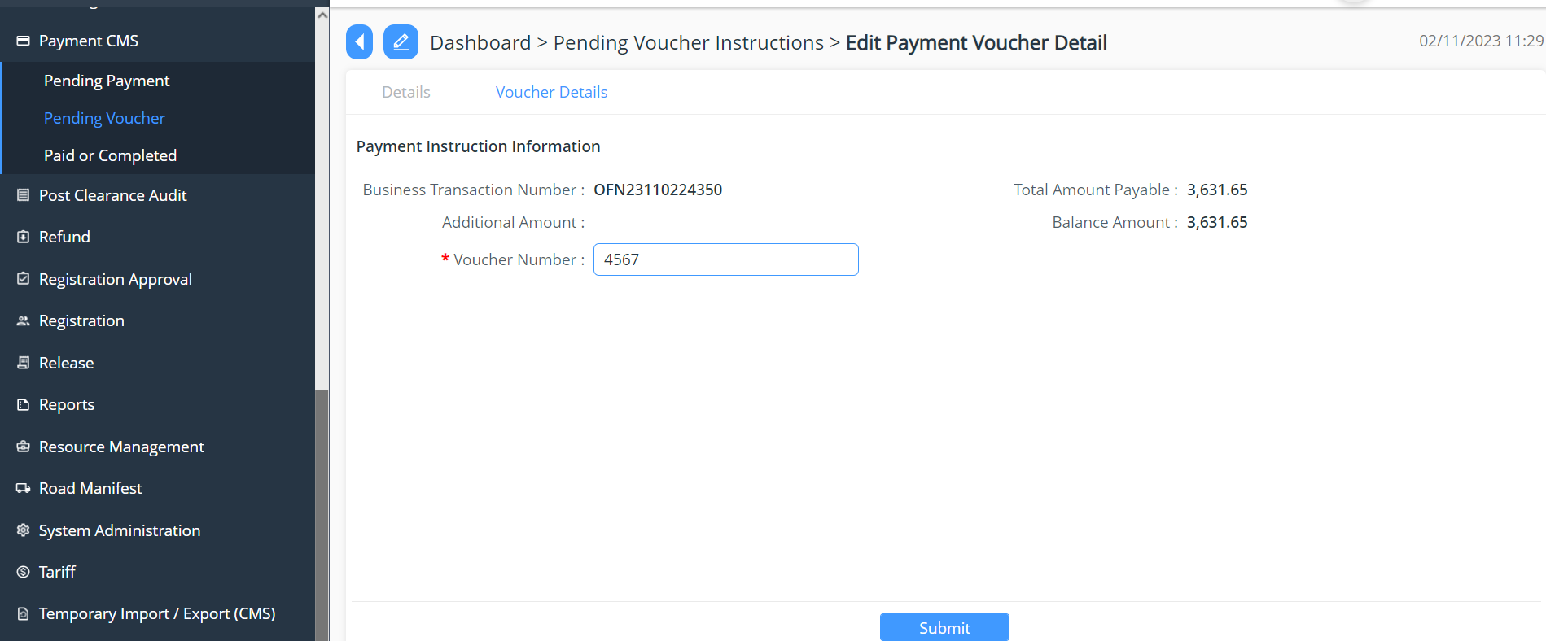
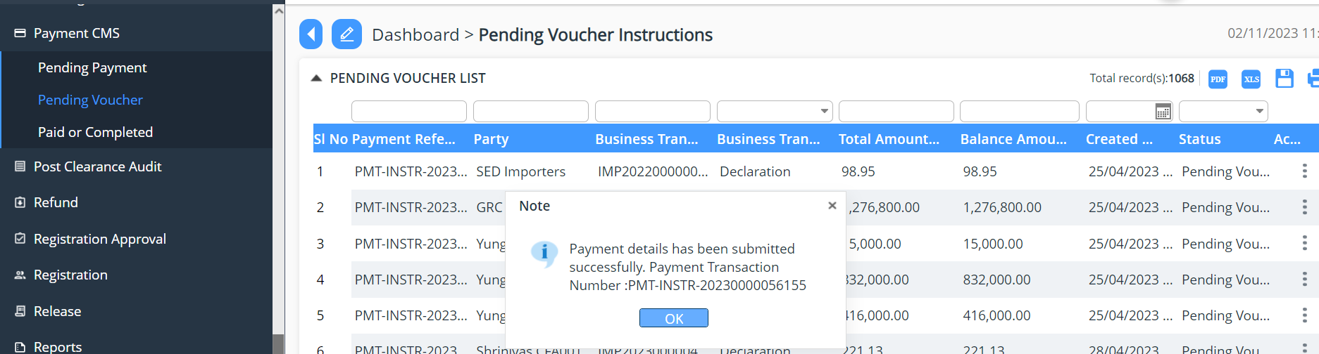
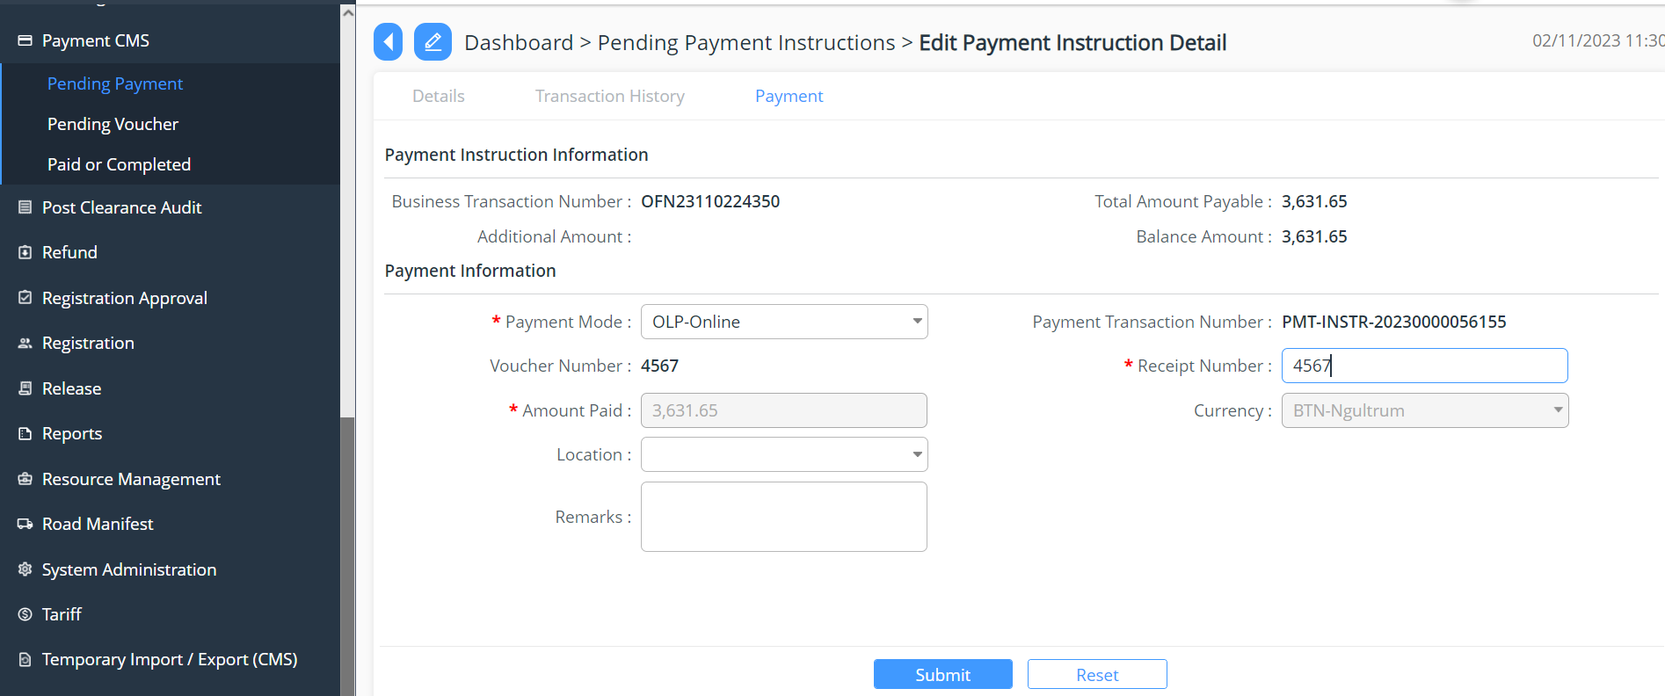
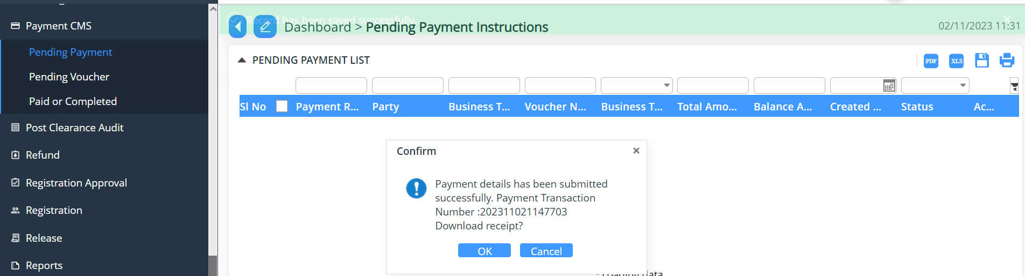

Release
The concern official will now check the offence and status now will be Released.

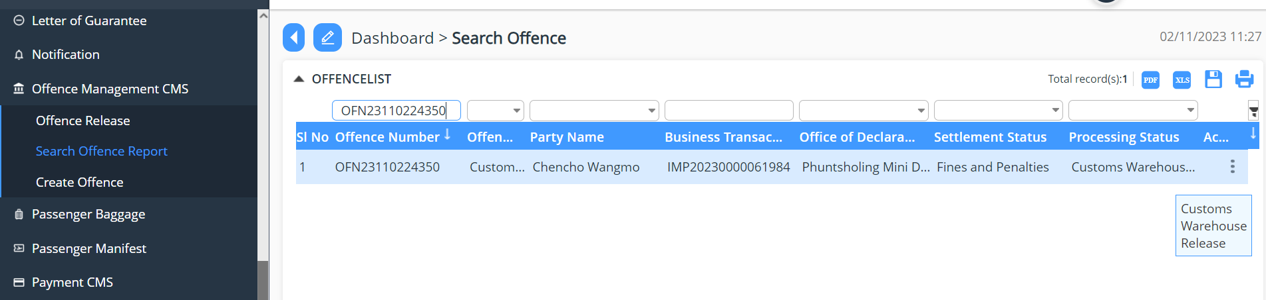

Status changed to Release the Official in charge of the Custom Warehouse, will release the goods accordingly.
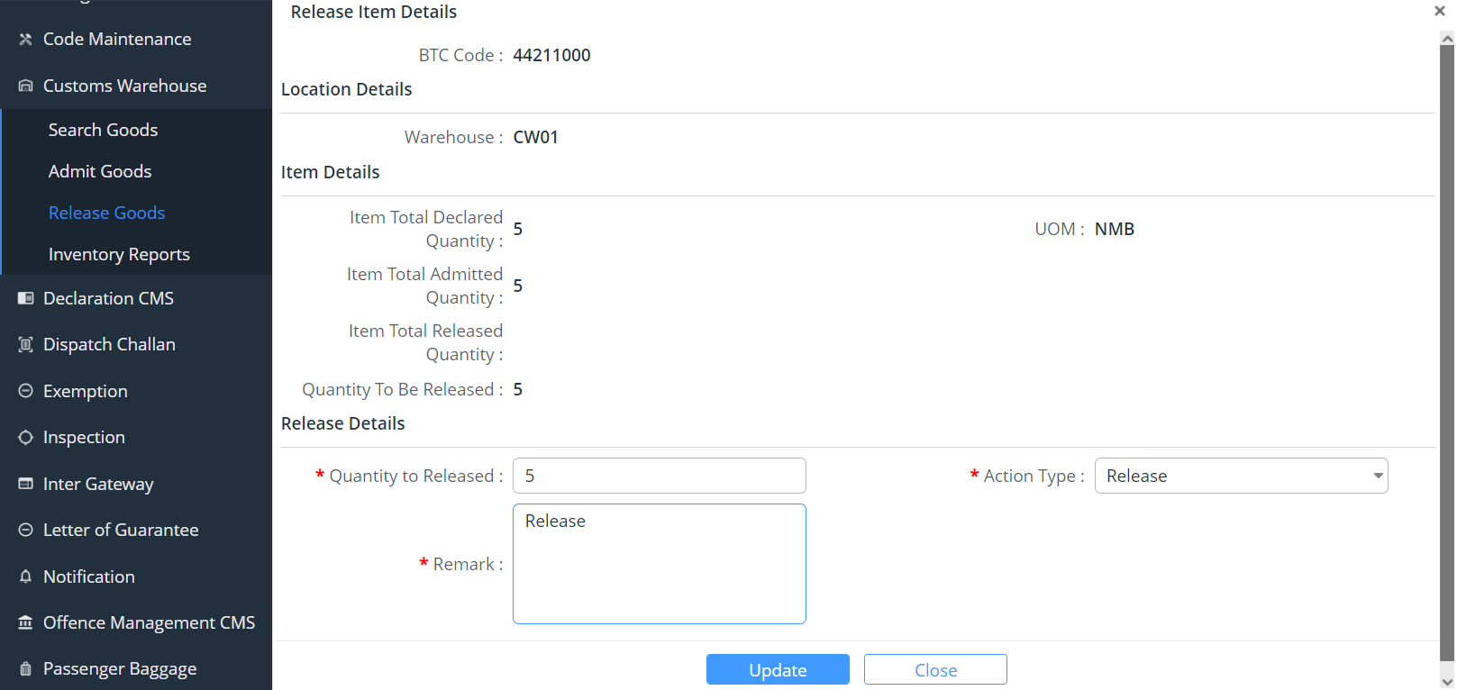
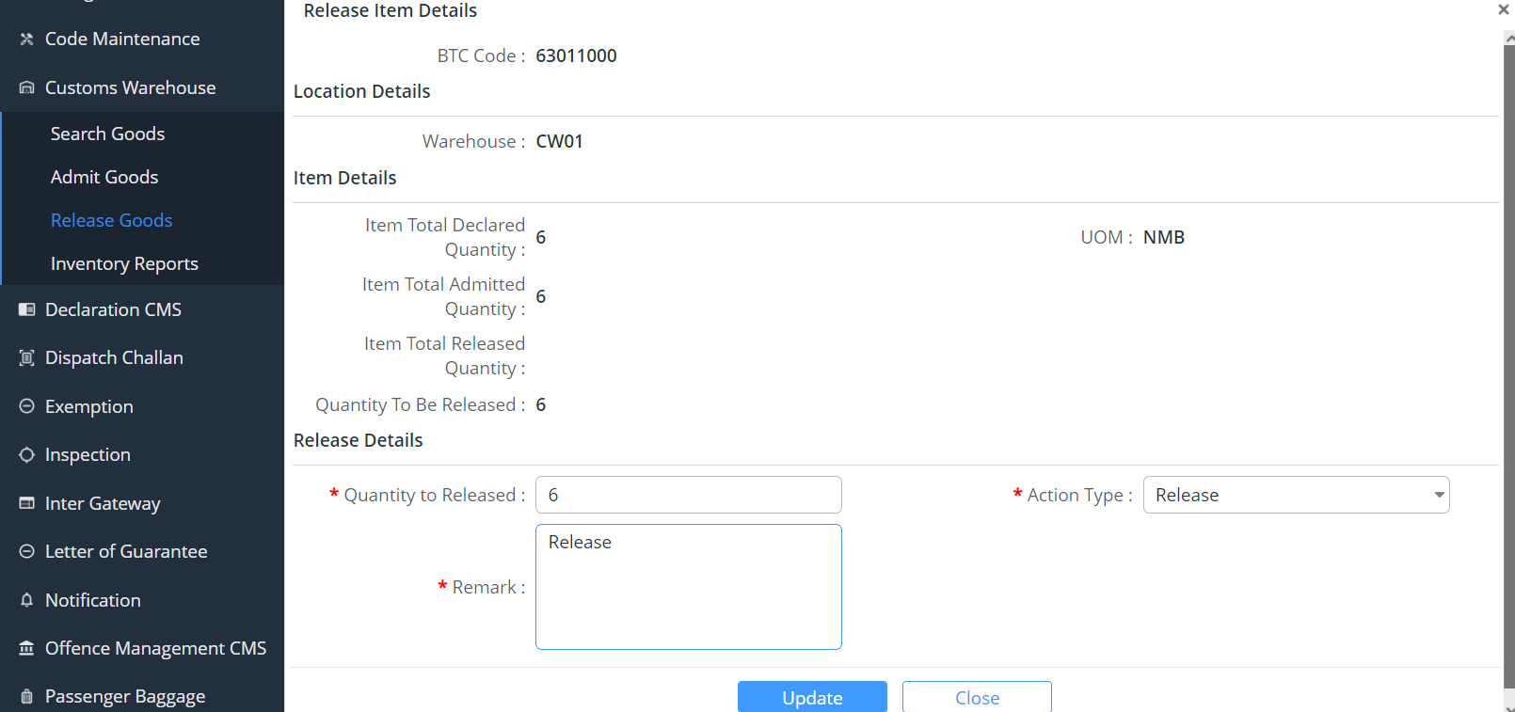

Once all release the offence status will be Closed.

